2-27-22 ARTICLE New Thinking About Student Engagement
December 6, 2021
•
5 min

Show & Tell: A Video Column / New Thinking About Student Engagement
Douglas Fisher,
Nancy Frey
- Abstract
- The Three-Dimensions Model
- Bridging Theory to Practice
- Teaching About Engagement
Research models show what engagement really looks like.
PREMIUM RESOURCE
ENGAGEMENT
CLASSROOM MANAGEMENT

Credit: PRESSMASTER / SHUTTERSTOCK
Consider how often classroom observation forms ask how many students are engaged during a lesson. Standard procedure is to look around the room and count the number of students who appear to be doing what they've been asked to do. The problem is that this limited view of engagement narrows a complex task to strictly outward signs of behavior. Are they looking at the teacher? Check. Taking notes? Check.
But what about that student looking out the window? Or the one rifling through a backpack? Are they engaged? The answer would seem to be no. But the window-gazing student could be thinking deeply about a rhetorical question the teacher just posed. And the topic at hand might have sparked a connection for the backpack-rifling student, who wanted to find her book to look at a key passage.
Herein lies the problem: Engagement isn't simply about low-level compliance. Indeed, existing and new research can help us understand engagement, and how to identify it, in a new light.

The Three-Dimensions Model
An older model of student engagement proposed by Appleton and colleagues suggests that it occurs across three dimensions: behavioral, cognitive, and affective.1 Behavioral engagement includes behaviors and actions. Readily observable indicators like participating in class discussion, following classroom rules, and completing assignments are frequently cited as evidence of this.
Cognitive engagement is an indicator of the psychological effort students exert. Cognitively engaged students are monitoring their understanding and making connections with the new learning. This is more difficult to identify based on outward actions only. That student who was gazing out the window might have in fact been cognitively engaged while reflecting on her learning.
A third dimension is affective engagement—how students feel about their learning. Students who are emotionally engaged are interested and curious about the content. Perhaps the student who pulled a book from her backpack had been surprised at some information the teacher shared and wanted to compare it to something previously read. She was responding emotionally to the content, eager to satisfy her curiosity.
Truly engaged learners draw on all three dimensions. A student who is only behaviorally engaged may go through the motions of schooling with little investment in the learning (yet look engaged). One who is cognitively but not affectively engaged may lack the will to persist when learning gets more difficult. And a learner who is only emotionally engaged may feel great interest in the subject but put forth little effort.

Bridging Theory to Practice
Though Appleton's model has much merit, teachers need a model that more explicitly bridges theoretical constructs to what engagement looks like in the classroom, so they can recognize engagement and teach students what it looks and feels like. Australian researcher Amy Berry has provided exactly that.2 Through interviews with teachers about their descriptions of indicators of engagement and disengagement, she developed a continuum of engagement and disengagement that weaves theoretical principles with classroom application (see Figure 1) and helps teachers gauge more precisely how much kids are engaged (or not) in learning.
Berry found most teachers centered on the "doing" aspect of learning—the behavioral dimension. But she recognized that a student's degree of passivity or activeness within school also influenced their investment in learning. She located behavioral-only engagement on the more passive end of her continuum and called this category "Participating." Some teachers also described passive disengagement, which led Berry to extend the continuum in another direction to create the passive disengagement category of "Withdrawing."
In addition, Berry found, students can be actively engaged or disengaged. Students with a somewhat high degree of active engagement ("Investing") ask questions about the content and seek relevance in what they're learning. Somewhat actively disengaged students ("Avoiding") try to evade work, such as with off-task behavior.

Video on Engagement
Show & Tell: A Video Column / New Thinking About Student Engagement - ASCD
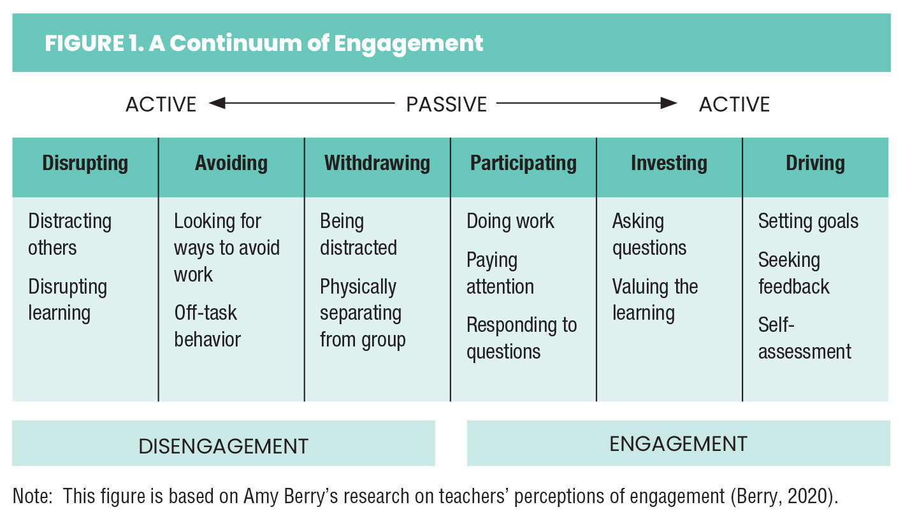
Now consider high levels of active disengagement and engagement. Those with a high degree of active disengagement disrupt learning for themselves—and maybe others. But students with an active stance and a high degree of engagement drive their own learning. They set goals, seek feedback, and gauge their learning.
Here's what's exciting: higher levels of active engagement correspond to better learning. The teachers Berry interviewed described their students' relative level of learning as it related to the active-engagement continuum. Students who were more actively disengaged, the teachers noted, learned less. Teachers saw that when students' engagement (even those in the "Disrupting" category) moved to the right on this continuum in a learning situation, this resulted in incremental increases in learning.

Teaching About Engagement
Berry's work has inspired some educators to teach students about how their own level of engagement influences their learning—and how they might progress. In the video that accompanies this column, high school history teacher Thomas Tutogi introduces the continuum to his students and allows them to co-construct indicators of engagement and disengagement. It's important to note that he teaches them about monitoring their own investment in their learning. He sets them up to self-assess their level of engagement at the end of every class and provide evidence for their claims.
Mr. Tutogi's students are learning to evaluate their own thinking and behavior in school and to self-regulate to help themselves learn better. Teaching students about the importance of true engagement, rather than compliance, could do a lot to foster student ownership of their learning.

