Have you begun to Reimagine Education?

LEADERSHIP

With Few Details But Big Ideas, US Sec. of Education Cardona Pushes Total Reimagining of Education

By Emily Tate Mar 9, 2022
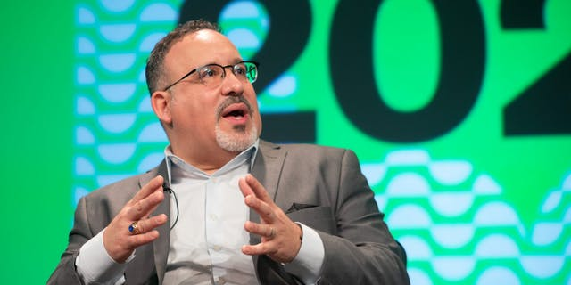

Education Secretary Miguel Cardona speaks at SXSW EDU in Austin, Texas, on March 9, 2022.
In the last two years, while schools experienced more disruption and strain than in almost any other time in recent memory, education leaders have been broadcasting one message, loud and clear and often: Education cannot go back to normal. This moment presents a chance to move forward, not go back. The upheaval of the pandemic can be an opportunity for positive change, if we let it.
As the weather warms and COVID cases plummet and classrooms return to full capacity, the moment of truth is near. And during a keynote panel at the SXSW EDU conference in Austin, Texas, on Wednesday, Education Secretary Miguel Cardona made sure to drill home the message to the hundreds of educators seated before him.
“We're closer to a reset in education than ever before. We've already been disrupted,” said Cardona, who worked as an educator and administrator in Connecticut before becoming Secretary in early 2021. “So why are we building it back the way it was when it didn't work for everybody?”
He added: “I want to make sure that as we see now, masks off and things are starting to look normal, that we do not lose our sense of urgency around not only the gaps that existed before, but the gaps that were made worse. So we need to really double down.”
The Secretary was scant on details when it came to how to make this happen, leaving some educators to point out afterward that the message is likely to fall flat without clear plans for implementation. But he emphasized that any improvements or “reimagining” of education should involve putting students at the center and giving educators more agency and respect.

Students at the Center
Alongside a panel of three local students—a high school senior in Austin, as well as two college students—whose education experiences were upended by COVID-19, Cardona reminded the audience that they are in this field doing this work to serve students. Yet, too often, educators don’t ask students what they need or want from their schools.
Cardona recommended shifting this dynamic to give students more voice and to support them not only by teaching content but by providing them with the critical mental health resources and social-emotional connections that so many young people need.
“We need to make sure that we're providing environments that meet their needs. 'Cause when those needs are being met, [students’] ability—their bandwidth—for learning exponentially increases. So those days of structuring our schools where student voice was marginalized have to be behind us,” Cardona said. “How are students’ voices driving the improvement work of a school? I think that's the question we have to ask as we move forward in education.”
The students on the panel were asked what they would change about education if they had Cardona’s job.
The high school student, Gesenia Alvarez from Travis High School, said she would “change the way teachers teach” so that it de-emphasizes rote memorization and encourages critical thinking.
The two college students both said they’d focus on making education more equitable, primarily by making it accessible and high-quality across the board.
“The system is broken,” said John Mark Wesley Hunter, a student at Austin Community College studying art and animation. “And so providing equal education for people so that they have equal opportunities, so that society isn't shutting them out, I think is really important.”

Embedding Support for Educators
Cardona knows as well as anyone that to be able to support students, educators must also feel supported. But for the last two years—and even before—many have felt quite the opposite of that.
Educators “need a chance to breathe as well and be supported,” Cardona said, before seeming to take aim at state legislatures that have recently proposed a flurry of bills restricting what educators can say or teach in the classroom on subjects such as LGBTQ issues and racism. “We can start respecting our educators. We can start by honoring them and not passing legislation that undermines our educators and our education system. We need to make sure that we're lifting up the profession.”
He mentioned giving teachers “a seat at the table” where decisions are made, as a way of bringing their voices in the fold and showing them that their expertise is truly valued and heard. He also acknowledged that educators have suffered and experienced trauma in the last two years, too, and that for them to be available to help students through their own trauma and challenges—including helping the more than 140,000 students who lost a parent or caregiver to COVID-19—educators’ needs must be addressed. “We need to make sure we're embedding better supports for our educators,” he said.
Cardona ended the hour-long conversation by noting that fellow educators are expecting him to make positive changes to the field, and by telling the audience that he intends to.
“I spent over 20 years in my education career pointing fingers and saying, ‘The system is broken.’ Well, now I represent the system. So it’s on me,” he said. “I take this job very seriously as a father, as an educator, as a Latino, to do as much as I can do now, so that generations later don’t have to deal with some of the issues we have.”
Emily Tate (@ByEmilyTate) is a senior reporter at EdSurge covering early childhood and K-12 education. Reach her at emily [at] edsurge [dot] com.

