DEPARTMENT OF CURRICULUM AND INSTRUCTION ENEWSLETTER
OCTOBER 2019

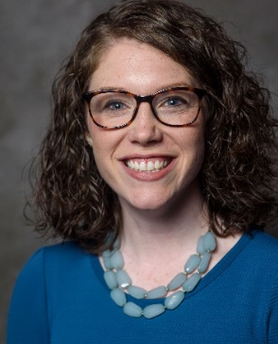
KERCH APPOINTED TO LITERACY TASK FORCE

Congratulations to Dr. Cailin Kerch upon her recent appointment by Alabama Department of Early Childhood Education Secretary Jeana Ross to serve on the Alabama State Department of Education Superintendent’s Literacy Task Force.

The task force was formed under a provision of the Alabama Literacy Act #2019-523 signed into law by Governor Kay Ivey on June 10, 2019. The goals of this act and the task force are to raise literacy and reading achievement for all Alabama’s children.

SECONDARY EDUCATION ALTERNATIVE MA PROGRAM ON
OIE ASSESSMENT HONOR ROLL

Secondary Curriculum Teaching and Learning’s (SCTL) Alternative Master’s Program has been recognized as one of 18 University academic programs to make the Office of Institutional Effectiveness’s (OIE) Assessment Honor Roll for its quality Assessment Plan and Report.

2019-2020 FULBRIGHT STUDENT AWARD WINNERS ANNOUNCED
Cheers to Madeline Willoughby and Courtney Geary for their selection as recipients of 2019-2020 Fulbright Student Awards. A total of ten university students and graduates were chosen for this award. Through the U. S. Fulbright program, individually designed study and research projects or English-teaching assistantships are funded to 160 countries.

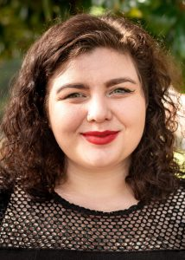
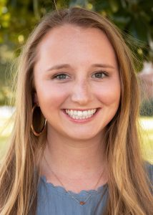
Madeline Willoughby (Houston, Texas), is a 2019 graduate in elementary education. As part of the program, she will be teaching in Malaysia.

Courtney Geary (Somerset, Pennsylvania), a University Fellow in the Honors College, a Blackburn Fellow and a 2019 graduate of New College majoring in interdisciplinary studies with minors in international studies and educational studies, was selected to teach in Jordan.

ABSTRACTION IN MODELING THROUGH SYNTHESIS (AiMS) PROJECT BENEFITS STRUGGLING SCIENCE TEACHERS
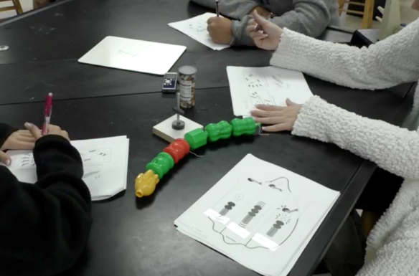

The AiMS project, a National Science Foundation-funded collaboration between Dr. Jonathan Shemwell of the College of Education at The University of Alabama and Dr. Daniel Capps at the University of Georgia, took its partnership activity “on the road” last summer to support a summer school program in Walton County, GA.
The focus of their effort was to better understand how modeling instruction can be used to support struggling teachers. It is the hope of Shemwell and Capps to continue their work in partnership schools in our region.
Alabama PhD student Carlson Coogler helped the classroom teachers enact modeling instruction, and she afterward interviewed students as they used their model-based knowledge to interpret science texts. She said of the overall experience: “It was eye-opening to listen to students using the model to interpret the text—especially as they navigated complex information and varied abstract language.”

ZELKOWSKI ENACTS NATIONAL SCIENCE FOUNDATION GRANT
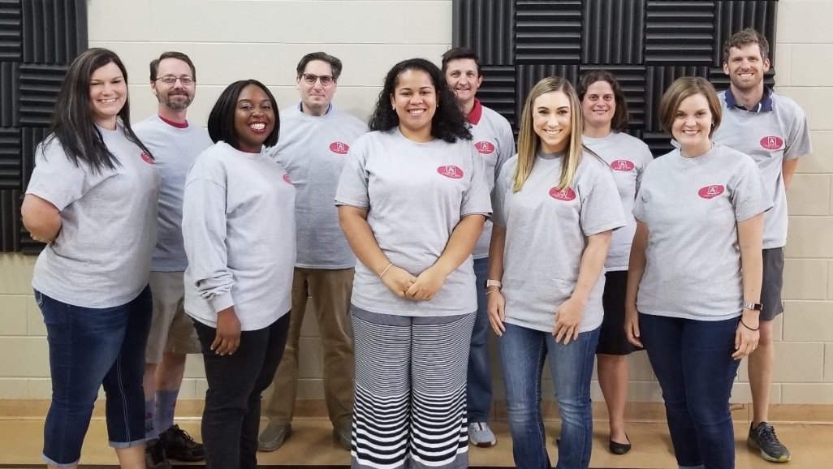

Dr. Jeremy Zelkowski, along with his colleagues from Educational Leadership and Mathematics, secured a $2.85M grant from the National Science Foundation in March 2019 in partnership with Tuscaloosa City and Tuscaloosa County Schools, Texas Instruments, and the Alabama Council of Teachers of Mathematics to develop 24 mathematics teacher leaders through the summer of 2025. The project title, Alabama’s Practitioner Leaders for Underserved Schools in Mathematics (A-PLUS in Math), recruited and started working with five area mathematics teachers in June.
The first Mathematics Teaching Fellowships (MTFs) were awarded to Jennifer Boyd, Bailey Avina, Kim Anderson, Stacy Allen, and Sarah Newton. They began their master’s degree program in secondary mathematics education funded completely by the grant. They enrolled in two master’s courses focusing on mathematical content and pedagogical practice this summer in which Dr. Jeremy Zelkowski and Dr. Jim Gleason co-taught each day and worked with each teacher to ready for the implementation of instructional units this school year. The MTFs will complete an additional master’s course each semester this academic year before returning June 2020 to campus when 19 additional MTFs join the project.
The leadership team in addition to Dr. Zelkowski includes Dr. Philip Westbrook, Dr. Martha Makowski, doctoral student and graduate research assistant Mr. Tye Campbell, National Board Teacher and Alabama Teacher of the Year Suzanne Culbreth, and external evaluator Dr. Bob Petrulis. The project team is currently actively circulating interest flyers and recruiting mathematics teachers for the additional 19 MTFs that will begin in June 2020 in the project. MTFs are supported with the full cost of tuition, an annual salary supplement of $12,575, professional travel support, covered costs of substitute teachers for project days, and classroom technology package from Texas Instruments.
The project website http://aplusinmath.ua.edu provides the project’s goals, intellectual merit, and broader impacts to the region. Interested mathematics teachers can reach out to Dr. Zelkowski and/or sign up for one of their fall webinar interest sessions on their website. Mathematics teachers outside the UA 50 mile radius who have interest in the potential to embark on this 5-year project, should contact Dr. Zelkowski through their project website.

SUH ENACTS NSF GRANT PROVIDING PROFESSIONAL
DEVELOPMENT TO ELEMENTARY TEACHERS
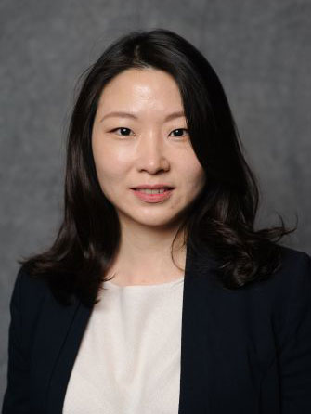

Dr. Jee Kyung Suh is participating in a four-year research project funded by the National Science Foundation (NSF).
The project began in May 2018 and seeks to understand how teachers develop adaptive expertise as they shift their epistemic orientations and develop knowledge of and practices for argument, language, and dialogical environment as epistemic tools for learning science. A total of 160 teachers and approximately 6,500 students in underserved areas of Alabama and Iowa will be involved in the project.
During the first year, Suh, principal investigator, developed and adapted three instruments assessing understanding of epistemic tools and collected baseline data. In Alabama, around 30 elementary teachers were recruited from six different school districts. The first round of summer workshops (six days) were completed between June and August 2019 on UA campus. The workshop provided various opportunities for the teachers to learn about use of language, dialogue, and argument as epistemic tools and pedagogical practices necessary for successful implementation of the Science Writing Heuristic approach.

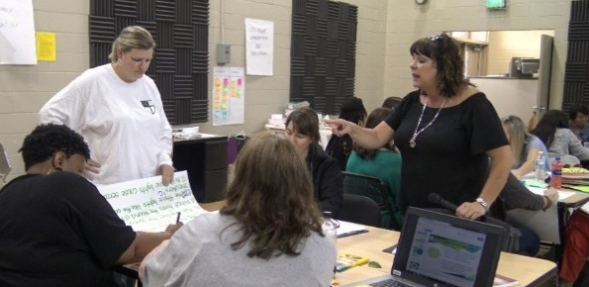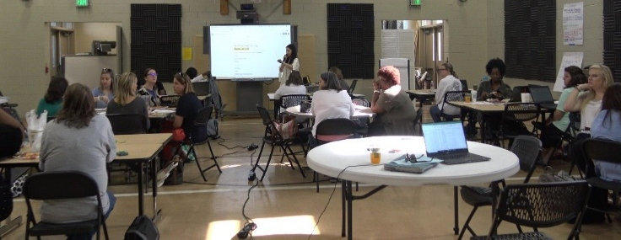

NEA FOUNDATION LEARNING AND LEADERSHIP GRANT
TO BENEFIT SOUTHVIEW ELEMENTARY SCHOOL
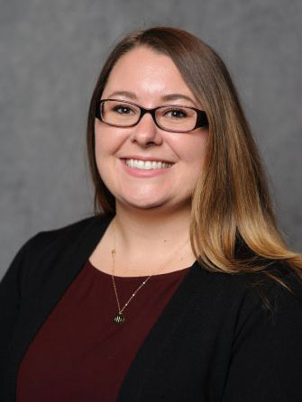
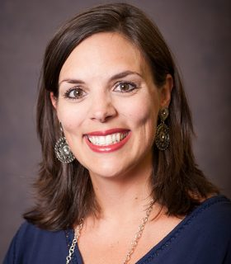
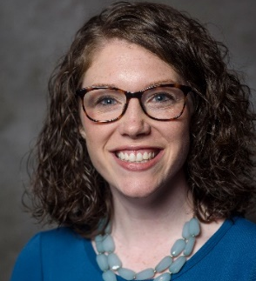

Drs. Cailin Kerch, Holly Swain, and Tracey Hodges are enacting an NEA Foundation Learning and Leadership Grant at Southview Elementary School with the support of the Office of School Partnerships, the Department of Curriculum and

Instruction, Dr. Carol Donovan, and the Belser-Parton Literacy Center.

Professional Learning Communities connecting fifth grade elementary teachers and university faculty will be implemented with the collaborative goal to enrich proficient readers’ comprehension using Notable Social Studies Trade Books and Outstanding Science Trade Books. Pre-service teachers in CEE 365: Literature for Children will help plan school-wide literacy nights for Southview children and families.

COLLEGE OF EDUCATION PARTNERS WITH
SOUTHVIEW ELEMENTARY SCHOOL
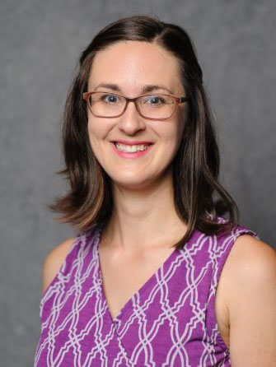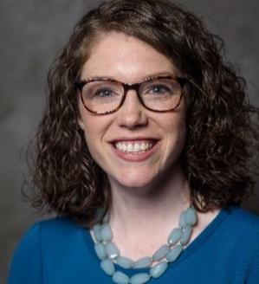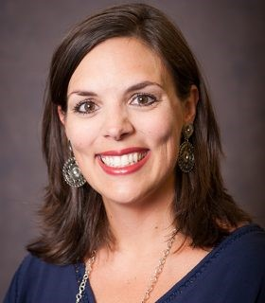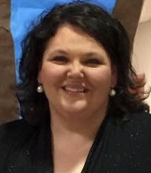

Drs. Alison Hooper, Cailin Kerch, Holly Swain, and doctoral student Melissa Walton are collaborating with Southview Elementary School’s Pre-Kindergarten classrooms in a newly established partnership with Tuscaloosa City Schools and The University of Alabama’s College of Education, sponsored by the Office of School Partnerships and the Department of Curriculum and Instruction.
Pre-service teachers meet weekly at Southview for CEE 492: Engaging Children and Families in the Early Childhood Classroom and have the opportunity to spend time in the school’s pre-kindergarten classrooms engaging with faculty, staff, and families.

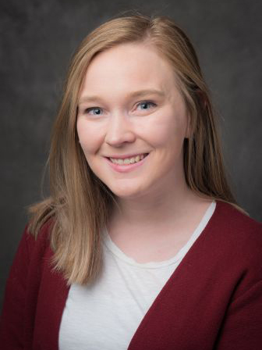
C&I WELCOMES NEW STAFF MEMBER

Ms. Virginia “Ginny” Prosch, an office associate in the Department of Curriculum and Instruction, grew up in Decatur, Alabama, and studied history and Spanish at Brigham Young University; later earning her master’s in Secondary Social Science Education at the University of Montevallo. Her interest in higher education began while she was coaching basketball and teaching at Chelsea Middle School. She is an avid supporter of animal rescue and sports fan.

Her hobbies include singing, practicing the guitar, history, all things Disney, and Harry Potter. In fact, she writes that she will soon be starting a Disney podcast along with her sister.

Ms. Prosch is excited to be working in the College and looks forward to getting to know faculty, staff, and students.

KERCH AND HOOPER ENGAGE IN MULTIPLE
COLLABORATIONS WITH THE ADECE
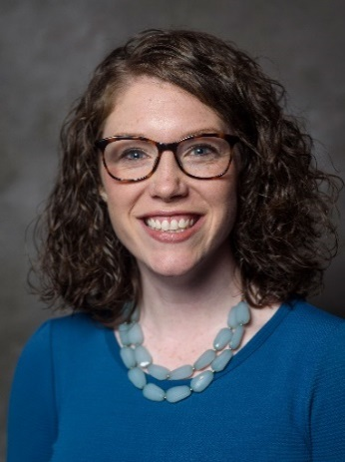
Drs. Cailin Kerch and Alison Hooper highlight the following collaborations with the Alabama Department of Early Childhood Education (ADECE):
- Completing the Accreditation Program for Trainers through Teaching Strategies GOLD Grant. Both Hooper and Kerch are now accredited to provide training on the Teaching Strategies GOLD assessment. This will benefit UA preservice teachers in early childhood/elementary education, who will be able to gain first-hand experiences using the GOLD assessment and interpretations of data in their courses. It will also benefit the early childhood workforce, as they will be providing free training on the GOLD to local early childhood educators in the community and optionally available to pre-service teachers. This semester, they will be completing a similar program to become trainers on the Creative Curriculum, both the infant/toddler and preschool versions.

- Dr. Kerch (PI), Dr. Hooper (co-PI), and Dr. Lee Winchester (co-PI) in the Kinesiology department received an ADECE grant to study the implementation of the Conscious Discipline program in state-funded Pre-K classrooms. Specifically, they will be examining the relationship between training in Conscious Discipline and teacher stress.

- Dr. Hooper received a grant from ADECE to complete the Train the Trainer Institute’s Program for Infant/Toddler Care (PITC).The goal of PITC is to help infant/toddler care teachers recognize the crucial importance of giving tender loving care and assisting in the infants’ intellectual development through an attentive reading of each child’s cues. Upon completing this training, she will hold a PITC credential, which will help further the early childhood/elementary education program’s work to and support preservice and inservice teachers in implementing high-quality teaching practices for infants and toddlers. The Early Childhood and Elementary Education undergraduates exit with a dual certification, including birth (P) to third grade (3) Early Childhood.

- Dr. Kerch co-facilitated the Alabama Early Learning Standards (birth through five years old) Cognitive Domain: Mathematics Committee and Relationship and Connections Domain: Social Emotional Development Committee from December 2018 through September 2019. ADECE partnered with regional and national early childhood experts to replace multiple early learning documents into a singular cohesive and inclusive early learning document for families and early childhood professionals. This document will feature a continuum from birth to third grade and has an anticipated release of January, 2020.

SUNAL, MUTUA, AND OLUSEYI PUBLISH BOOK TRANSFORMING PUBLIC EDUCATION IN AFRICA, THE CARIBBEAN, AND THE MIDDLE EAST

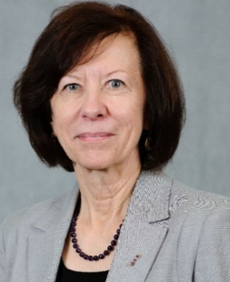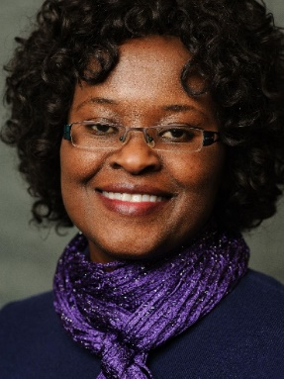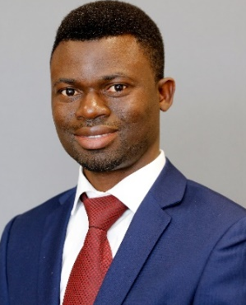

Sunal, C., Mutua, K., & Oluseyi, M. O. (2019). Transforming public education in Africa, the Caribbean, and the Middle East. Information Age Publishing.

Public education has expanded to serve large populations across the regions of Africa, the Caribbean, and the Middle East. Many nations in these regions are moving into a phase of public education in which a variety of factors are being identified as influencing the quality of public education and its ability to serve all children and adolescents. It has become evident that ethnic background, gender, religious affiliation, and ability/disability are important factors in who is served and how well the individual is served.

The chapters in this edited volume, Book 8, of Research on Education in Africa, the Caribbean, and the Middle East document and describe the status, success, and limitations of public education’s efforts at transformation in these three world regions. They provide points from which further research and practice might occur.
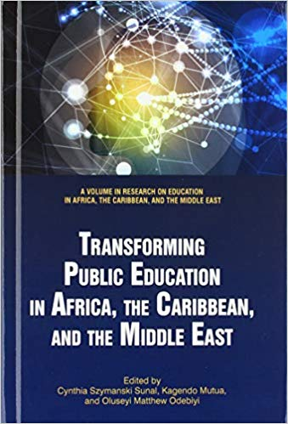

UA NOYCE FELLOWS ATTEND SOUTHEASTERN REGIONAL NOYCE CONFERENCE
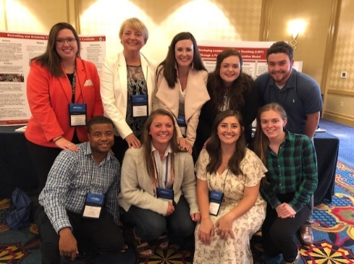
Several UA students were invited to the Southeastern Regional Noyce Conference (SENOYCE) in Mobile, Alabama as Noyce Fellows. In addition to being honored, each attendee participated in a poster presentation. UA attendees included Haley Harville-York, Hakim Hawkins, Garrett Pinkerton, Andrea Shull, Kelsey Smith, Cynthia Sunal, Dennis Sunal, Marilyn Stephens, Rachel Tawbrush, Lily Walker, and Megan Zeier.
NEW BOOK CHALLENGES PHYSICS TEACHING AND LEARNING METHODS
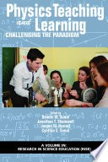

Sunal, D. W., Shemwell, J. T., & Harrell, J. W., & Sunal, C. S. (2019). Physics teaching and learning: Challenging the paradigm.

A new book focuses on research contributions challenging the basic assumptions, ways of thinking, and practices commonly accepted in physics education. Teaching physics involves multifaceted, research-based, value added strategies designed to improve academic engagement and depth of learning. In this volume, researchers, teaching and curriculum reformers, and reform implementers discuss a range of important issues.

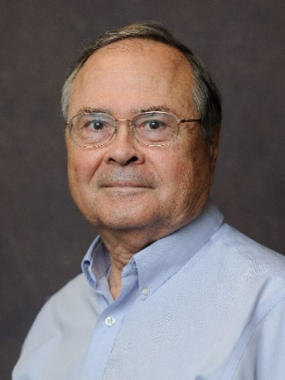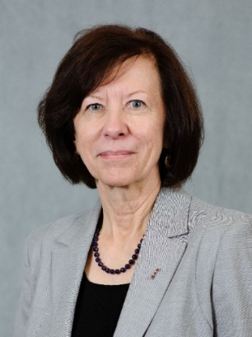

PRE-SERVICE TEACHERS TOUR TCS SUMMER LEARNING PROGRAMS

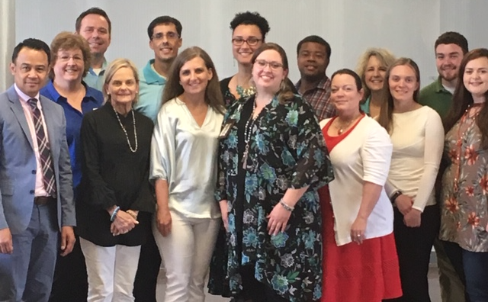

Faculty and pre-service teachers taking CSE 390 attended a tour of the Tuscaloosa City Schools Summer Learning Academies. Participants were given the opportunity to observe students engaging in summer enrichment programs provided by the Tuscaloosa City School System. These programs include academic instruction, hands-on activities, and meals for TCS K-12 students.

ELEMENTARY LITERACY STUDY ABROAD TRIP TAKES
UA STUDENTS TO THE UK AND FRANCE

Dr. Holly Swain and eleven UA students traveled across the UK and France last May and early June as part of a literacy study abroad trip focused on exploring the historical, social, political, and geographical origins and influences of children’s literature. A highlight of the trip for many students was participating in a read-aloud at an English school.
One student, Taylor Guyton, writes, “My favorite day in England was the teaching day. I love being in the classroom anyway but learning about methods that St. Martin’s teachers use to prepare their students for their entrance exams was so interesting because it differed so much from American methods. It was obvious to all of us that their methods were effective because of the way the students responded to questions, but it was also obvious due to how much the students ASKED questions.”
Notable stops included visiting literary character monuments such as the Paddington Bear Statue in Paddington Station, the Peter Pan statue in Kensington Gardens, and the Sherlock Holmes statues at Baker Street tube station. Students also visited the London Eye, Buckingham Palace, and enjoyed a nighttime Seine river cruise.

