Cloud-Based Chemical Inventory Management
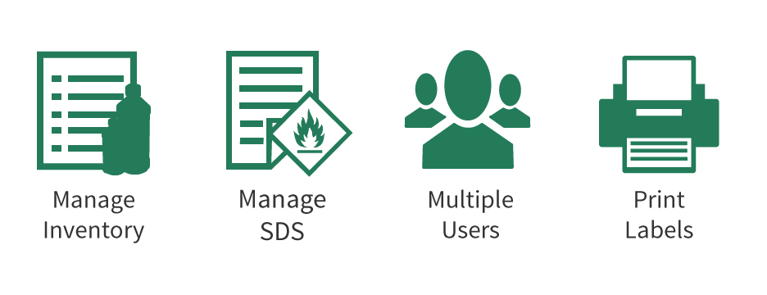

Online Chemventory Features and Benefits
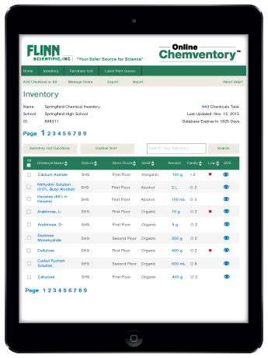
Flinn Online Chemventory™ is a cloud-based inventory system for laboratory chemicals that allows multiple users access to a single chemical inventory database from multiple locations and multiple devices! Maintaining an accurate chemical inventory has never been easier, more flexible, or more convenient.
New Version 2.0 Update Included! Flinn Online Chemventory™ has been updated with additional features and conveniences:
- Add any of our 800+ laboratory and demonstration kits to your inventory list.
- If all the chemicals from your kit are not used there is an easy option to move those leftover items from the kit listing into your inventory.
- Perform tasks such as printing SDS sheets for multiple chemicals with one click.
- Custom sort your inventory to see a quick view of all chemicals that are low in stock.
- Improved search function of your database and also the Flinn master chemical list.
The program comes fully loaded with updated GHS pictograms, hazard codes, and signal word information for over 2,400 Flinn chemicals. Build your inventory by selecting from a list of Flinn chemicals or add your own chemical information manually. Now you can build an inventory database for your school and invite other teachers, lab assistants, and administrators to join for free.
Best of all, we have included an updated GHS label printing feature in Online Chemventory. Print a GHS-compliant label for any Flinn chemical listed in your inventory or any of our 2,400+ Flinn chemicals listed in the program. You can also take advantage of our chemical solution label printing options to easily keep track of all the solutions you prepare in your lab.
View and print a detailed description of all the included features
- P.O.Box 219, Batavia, IL 60510
- Phone:1-800-452-1261
- Fax:1-866-452-1436
- flinn@flinnsci.com
- Flinn Home Page

- FAQs

- Contact Us

- Online Chemventory Home
- Inventory

- Log In

- Label Print Queue
©2013- 2021 Flinn Scientific, Inc.

