‘What, me racist?’ Florida posts 4 lessons to explain rejected math textbooks

‘What, me racist?’ Florida posts 4 lessons to explain rejected math textbooks
Lessons flagged by Florida education officials include a formula for self-assessing racial bias.
By: Matt Zalaznick | April 22, 2022

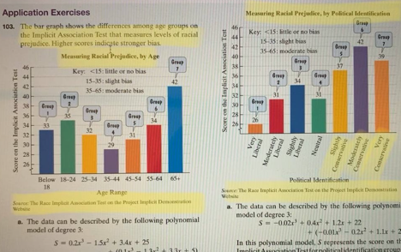

This math lesson, which graphs how people scored on a racial bias assessment, was cited by Florida officials as an example of why it rejected more than 50 math textbooks.

What? Me? Racist? That’s one of the lines in a math lesson that appears to have fueled the controversial rejection of dozens of textbooks by Florida education officials last week. Another page flagged by the state encourages students to build empathy with classmates.
The state’s Department of Education has come under fire for offering few details beyond citing critical race theory, social-emotional learning and Common Core as reasons for scrapping the textbook. Many of the books are intended for the elementary grades and were published by leading education companies such as Houghton Mifflin Harcourt and McGraw Hill. Though more than 50 texts were rejected, the agency posted just four brief examples Thursday of what its curriculum reviewers considered problematic.
“The Department is continuing to give publishers the opportunity to remediate all deficiencies identified during the review to ensure the broadest selection of high-quality instructional materials are available to the school districts and Florida’s students,” the agency said, adding the examples of the rejected lessons were provided by “the public.”
The “What? Me? Racist” page introduces students to a formula that a person can use to assess their own level of racial bias. It notes that the majority of people who have taken the test have scored “slight” or “moderate.” Another lesson shows a graph of racial bias scores based on age and political orientation. It shows that people who identified as very liberal and moderately liberal had lower bias scores than conservatives.
Another page breaks a lesson down by its academic, language and social-emotional learning objectives. The SEL objective says: “Students build efficiency with social awareness as they practice empathizing with classmates.” The final lesson explains that SEL builds student agency by focusing on five competencies developed by CASEL, a nonprofit that has been a pioneer in guiding educators to incorporate social-emotional learning into everyday instruction.
In The New York Times’ analysis of 21 of the rejected textbooks, its reporters found a McGraw Hill fifth-grade lesson that encourages students to deal with math anxiety by reflecting on how math skills apply to their hobbies and other interests. The Times also noted an eighth-grade pre-algebra lesson that contained a biography of Dorothy Johnson Vaughan, an African American mathematician who worked for NASA’s predecessor.

Earlier in the week, Andrew Spar, president of the Florida Education Association, demanded on Twitter that the state better define social-emotional learning and critical race theory and provide details about the qualifications of its textbook reviewers.

