Article Periodic Table
https://www.sciencenewsforstudents.org/article/scientists-say-periodic-table
SCIENTISTS SAY CHEMISTRY

Scientists Say: Periodic table

This is a chart of the chemical elements arranged by their properties
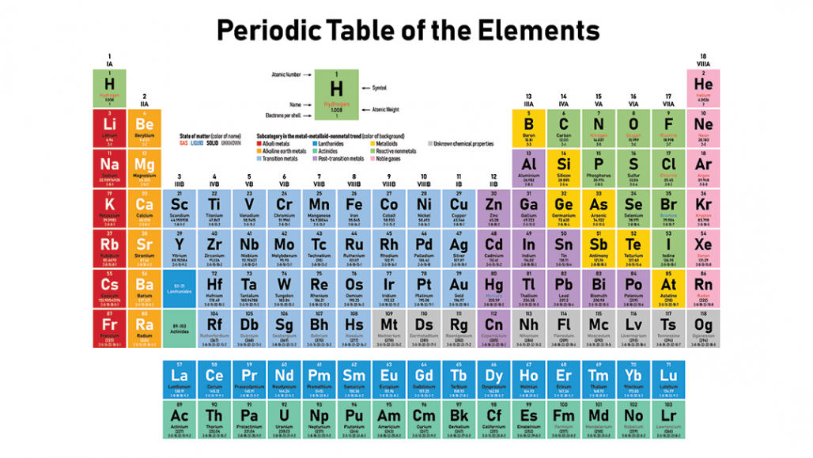
In the periodic table, elements are lined up by atomic number, the number of protons they have. An element’s location in the table relates to its reactivity and how its electrons are arranged.

DUNTARO/ISTOCK/GETTY IMAGES PLUS
By Carolyn Wilke
October 14, 2019 at 5:46 am

Periodic table (noun, “peer-ee-AHH-dik TAY-bul”)
This is a chart that shows all the known chemical elements. The table is made up of over a hundred squares. Each square represents one element. A square contains one or two letters that stand for the element’s name, and numbers that tell about that element’s properties.
The location of each square in the table tells many things about each element. First, the elements are organized by atomic number, or how many protons they have. Those on top of the chart have the fewest protons. An element’s place also shows how likely it is to react. It also shows how its electrons are arranged.
During the mid-1800s, many chemists looked for patterns that explained how elements interacted. Back then, scientists didn’t know about the protons, neutrons and electrons that make up atoms. But they did understand that elements had different atomic weights. An atomic weight is the average weight of one atom of an element.
In 1869, the Russian chemist Dimitri Mendeleev lined up the 63 known elements in order by their atomic weights. He saw trends in the elements’ properties that varied over specific intervals, or periods. Other scientists were working on their own periodic tables, but Mendeleev published his table first.
The periodic table continued to grow as scientists discovered more elements. These include the noble gases, identified in 1890. This is a group of elements such as helium that don’t like to react with other elements. Starting in the 1940s, scientists found many new elements by colliding atoms or pieces of atoms.
At the end of 2018, chemists confirmed four elements that had never been observed before. That brought the number of known elements to 118 and completed the 7th row of the table.

In a sentence
The year 2019 marks the 150th anniversary of the periodic table, first conceived in 1869.
Check out the full list of Scientists Say.

Power Words
More About Power Words
atom The basic unit of a chemical element. Atoms are made up of a dense nucleus that contains positively charged protons and uncharged neutrons. The nucleus is orbited by a cloud of negatively charged electrons.
atomic Having to do with atoms, the smallest possible unit that makes up a chemical element.
atomic number The number of protons in an atomic nucleus, which determines the type of atom and how it behaves.
average (in science) A term for the arithmetic mean, which is the sum of a group of numbers that is then divided by the size of the group.
chemical A substance formed from two or more atoms that unite (bond) in a fixed proportion and structure. For example, water is a chemical made when two hydrogen atoms bond to one oxygen atom. Its chemical formula is H₂O. Chemical also can be an adjective to describe properties of materials that are the result of various reactions between different compounds.
electron A negatively charged particle, usually found orbiting the outer regions of an atom; also, the carrier of electricity within solids.
element (in chemistry) Each of more than one hundred substances for which the smallest unit of each is a single atom. Examples include hydrogen, oxygen, carbon, lithium and uranium.
neutron A subatomic particle carrying no electric charge that is one of the basic pieces of matter. Neutrons belong to the family of particles known as hadrons.
proton A subatomic particle that is one of the basic building blocks of the atoms that make up matter. Protons belong to the family of particles known as hadrons.

About Carolyn Wilke
- E-mail
- Twitter
Carolyn Wilke is a former staff writer at Science News for Students. She has a Ph.D. in environmental engineering. Carolyn enjoys writing about chemistry, microbes and the environment. She also loves playing with her cat.

