Probes to understand student thinking
Useful materials to begin a science lesson with. These make excellent activities for the Exploration part of a science Learning Cycle lesson plan. Go to Browse by Topic below. See sample lesson plans. NSTA book materials also available.

NSTA

Understand Student Thinking & Transform Your Teaching with Easy-To-Use Digital Diagnostic Tools
Probes are intrinsically interesting questions that reveal what all students are thinking, uncovering initial ideas and misconceptions about core concepts and familiar phenomena that students bring to their learning. Teachers can now access digital versions of the popular formative assessment probes found in the bestselling NSTA Press series Uncovering Student Ideas. Loaded with classroom-friendly features you can use immediately, each digital probe integrates with Google Classroom, includes interactive PDFs, and is available in both English and Spanish. The detailed Teacher Notes that accompany each probe include current research summaries, new instructional suggestions, and related NSTA resources.
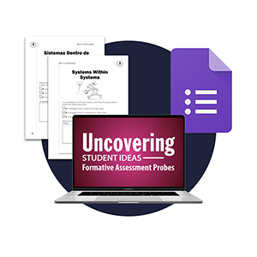
- Probes

Latest Probes

Lesson Plan
Model of Air Inside a Jar
The purpose of this assessment probe is to elicit students’ ideas about the particle model of matter. The probe is designed to find out if students ...

Lesson Plan
Global Warming
The purpose of this assessment probe is to elicit students’ ideas about global warming. The probe is designed to find out what students think contri...

Lesson Plan
What’s Inside Our Solar System?
The purpose of this assessment probe is to elicit students’ ideas about the solar system. The probe is designed to find out if students can distingu...

Lesson Plan
The Greenhouse Effect
The purpose of this assessment probe is to elicit students’ ideas about the greenhouse effect. The probe is designed to reveal whether students conf...

Browse By Topic

Earth & Space Science
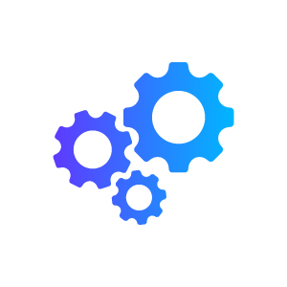

Engineering

Life Science

Physical Science

