More than half of first-time teachers in Alabama leave within 3 years

DIVE BRIEF

More than half of first-time teachers in Alabama leave within 3 years
Published April 29, 2022
Anna MerodAssociate Editor

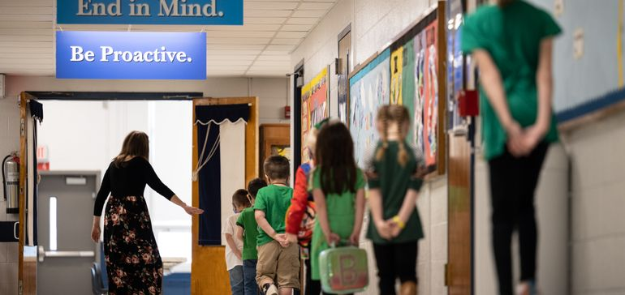

Dive Brief:
- More than 50% of first-time teachers in Alabama exit within three years on the job, according to a new teacher shortage interim report by the Alabama Commission on the Evaluation of Services.
- The first-time teacher turnover rate in Alabama exceeds the national rate — 44% — for teachers who leave during their first five years of employment, ACES found.
- It costs $9,000 to $40,000 to replace each teacher, according to ACES, meaning it likely cost $146 million to $652 million to replace the 16,305 new teachers who left their first teaching jobs in Alabama in the past 10 years, the report said.

Dive Insight:
The commission’s report paints a clearer picture than previously available of the teacher shortage crisis in Alabama, said Amber Bullock, policy lead at ACES, which was formed in 2019 by state policymakers to inform the legislature and governor about the state’s services. But the findings also show there’s still a lot more statewide data collection that could be mandated regarding teacher vacancies — and not just in Alabama, Bullock said.
This report shows Alabama is losing teachers sooner and faster than the national rate, which makes the current turnover rate in the state “terrifying,” Bullock said.
“It’s threatening our resources, and then our resources are depleting,” she said. “Not only are we bleeding out teachers, we’re bleeding out money to replace them.”
Even if the statewide retention rate increased by just 10 percentage points, Bullock said, that would be a noticeable improvement for keeping teachers in Alabama.
The findings on first-time teacher turnovers didn’t surprise Megan Boren, a project manager at the Southern Regional Education Board, a nonprofit working with 16 different states to improve public education.
The concerning teacher turnover rate in Alabama aligns with other data and research SREB has collected on the issue in the South, Boren said. SREB has interviewed educators throughout the region for the past five years, said Boren, and found teachers are under a lot of stress that has only been worsened by the pandemic.
Teachers “are receiving less support year over year. They do not feel like they have the respect and appreciation from the general public, policymakers or even in some cases education leaders,” Boren said.
New teachers need smaller classrooms and the ability to participate in a mandated mentorship program, she added.
“They should be placed in classrooms where they can have a bit lighter load, so to speak, those first few years and really learn and hone their craft before they’re given extra challenges,” Boren said.
Bullock said there’s potential to explore data from a teacher mentoring program being piloted in seven districts in Alabama to help retain new teachers.
Recently, state legislators approved a pay bump for Alabama teachers. Starting Oct. 1, educators with less than 9 years of experience will receive a pay increase of 4% and teachers with more than 9 years in the classroom will receive raises between 5% to 21% depending on experience, AL.com reported.
Alabama has one of the highest average starting teacher salary rates compared to its neighboring states, at $41,028 average, according to SREB’s teacher compensation dashboard.
“Any pay raise will certainly help,” Boren said, but it’s not the only factor keeping teachers in the classroom. Teachers also need professional development and collegial support, and they need to feel appreciated, she said.
Alabama is hardly alone on the teacher turnover issue, Boren said, and most Southern states are trailing nationwide data on turnover rates and teacher experience.
“There’s kind of an alarming trend that despite the fact that many states are raising compensation, they’re trying to change policy, they’re trying to do what they feel like they can do to stop or to reverse the teacher shortage trend,” she said. “It’s not quite working yet. The numbers are still getting worse each year.”
– Anna Merod @AnnaMerod

